**CSA1518-CLOUD COMPUTING**

V.Mrudula

192011395

**EXPT-20**

Create a SQL storage service and perform a basic query using any Public Cloud Service Provider (Azure/GCP/AWS) to demonstrate Database as a Service (DaaS)

**IMPLEMENTATION:**

STEP-1

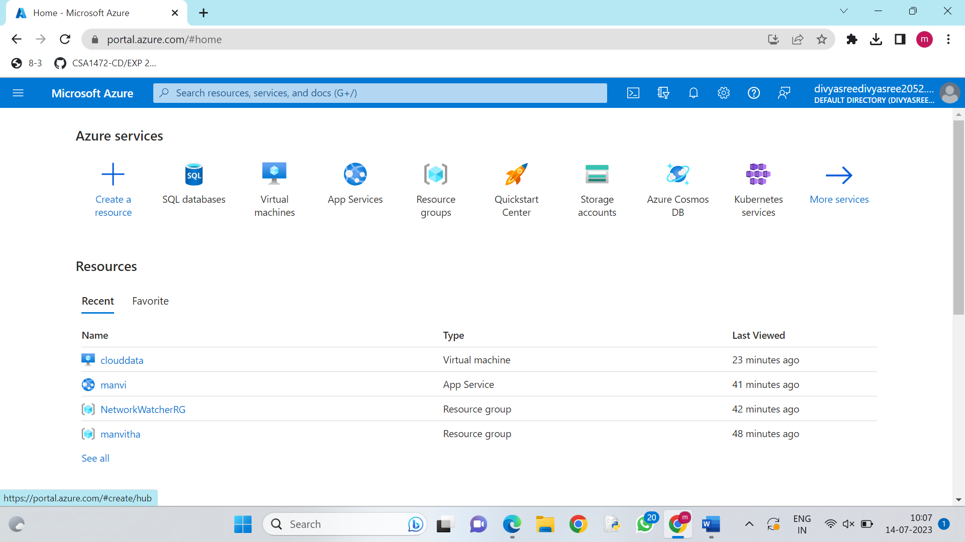

STEP-2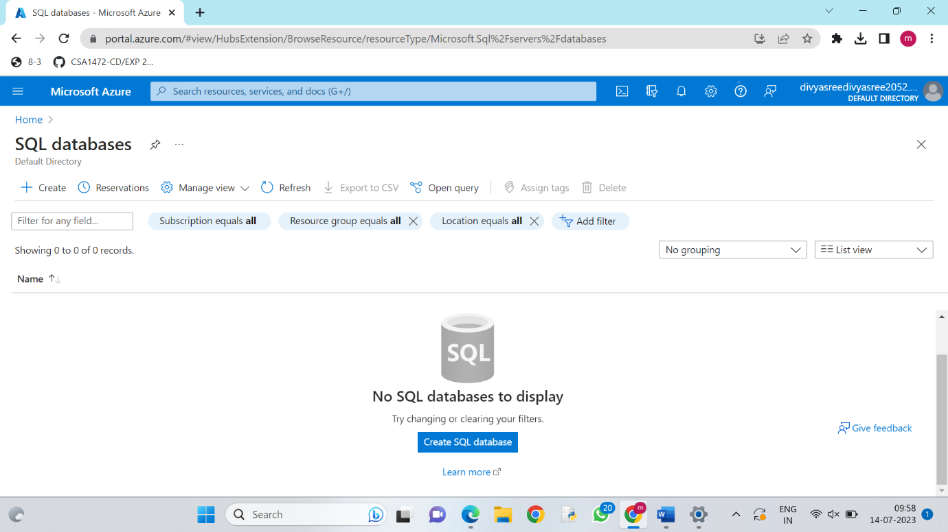

STEP-3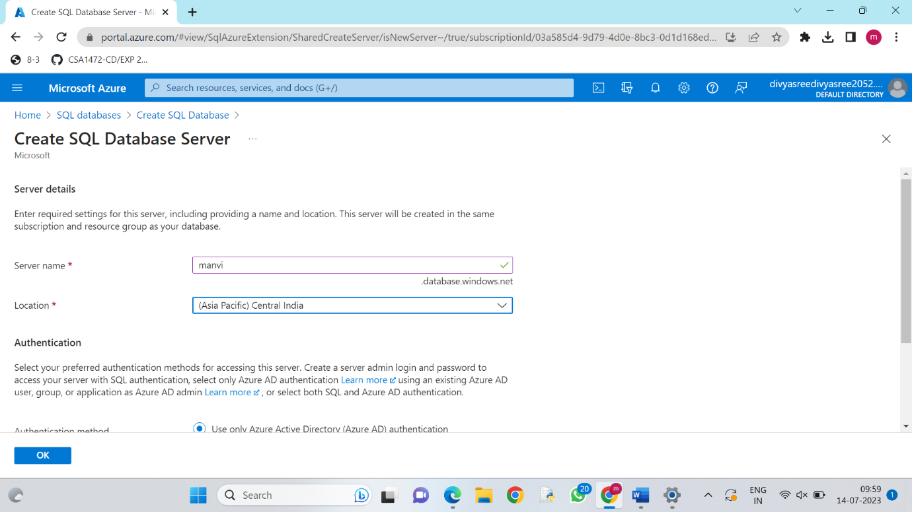

STEP-4

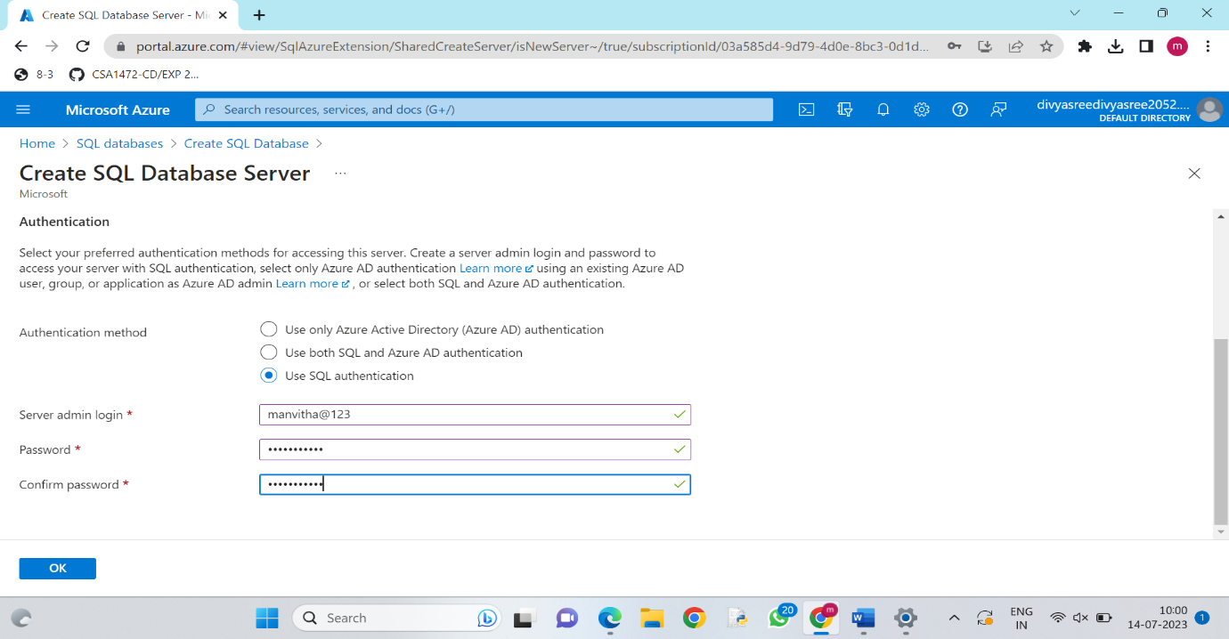

STEP-5

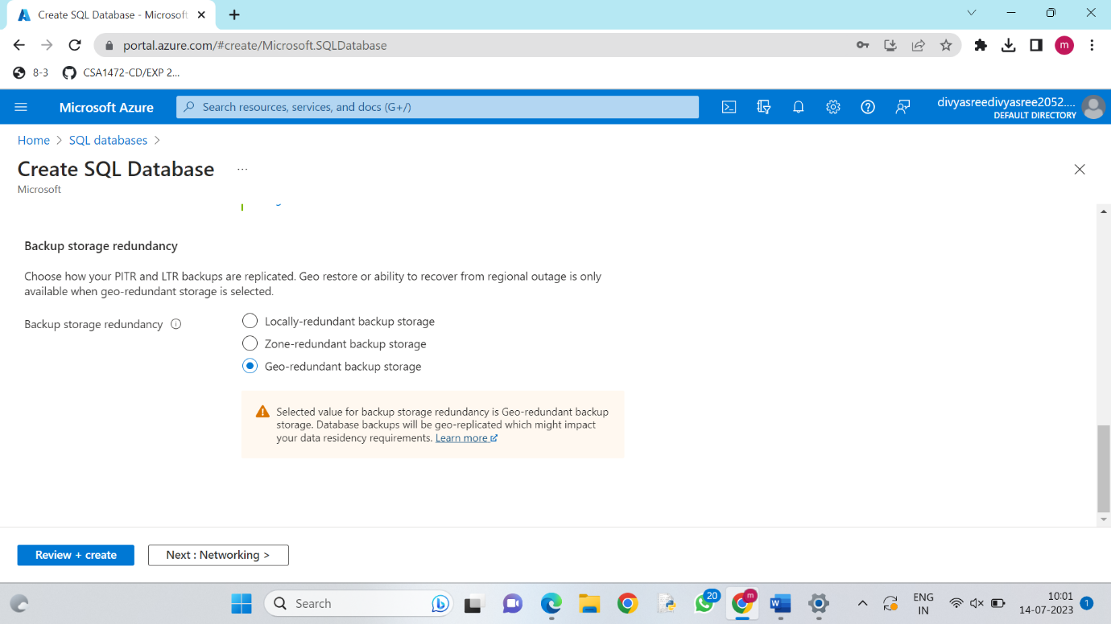

STEP-6

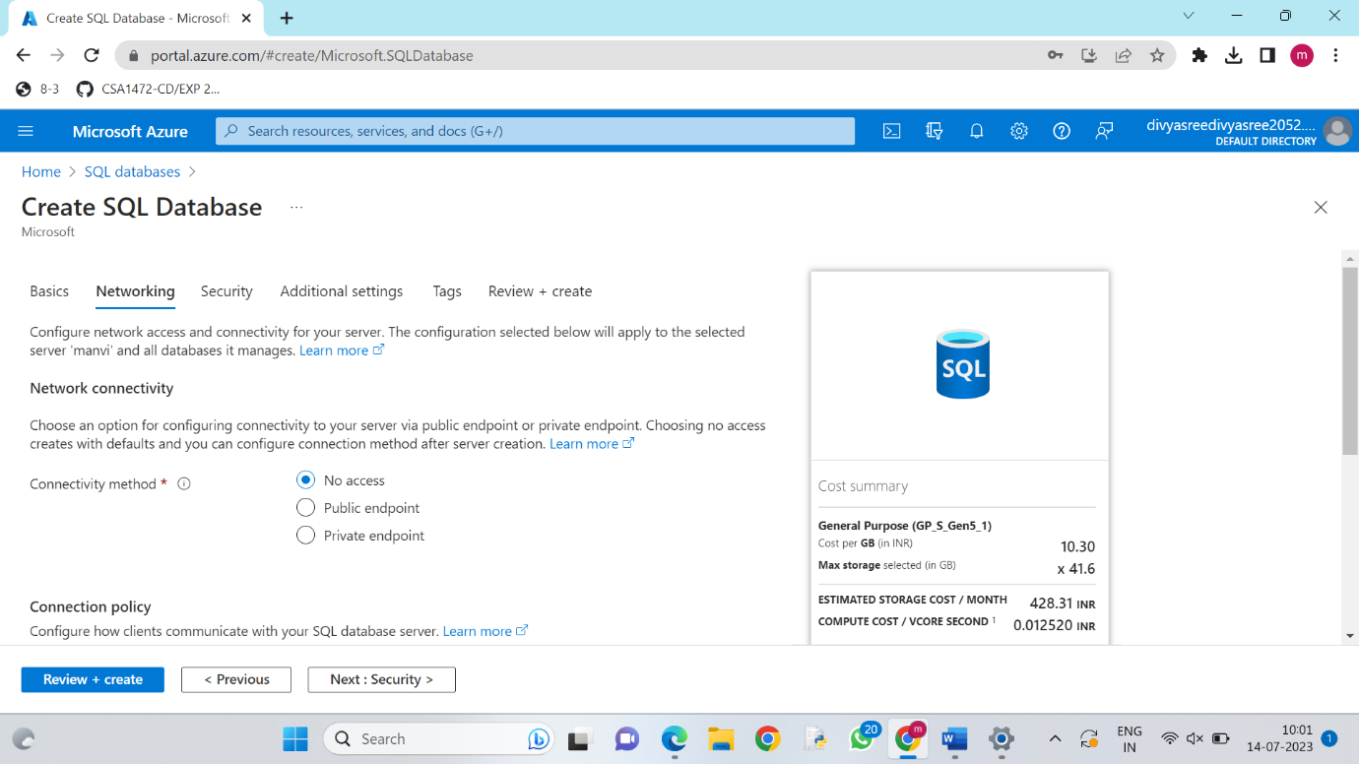

STEP-7

Create and review the SQL Database.